|  |  |
| --- | --- |
| **Beirut Arab University**  **Faculty of Science**  **Computer Science Department** | **Course:**  CMPS441-Fundamentals of Algorithm  **Semester:** Fall 2024-2025  **Lab4** |

**Part I:**

1. Using substitution method, determine a tight asymptotic lower bound for the following recurrence:

i. T(n) = 4T(n/2) + n2

ii. T(n) = 2T(n/2) + n.

Solution:

1. Let us guess that T(n)=n2lg(n). Then our hypothesis is that there exists c and k such that T(n)≥ cn2lg(n) ∀ c>0 and n≥ k.

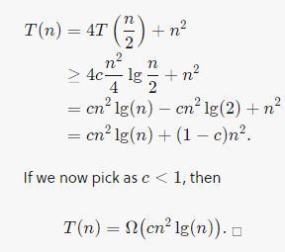

1. **Step1**: 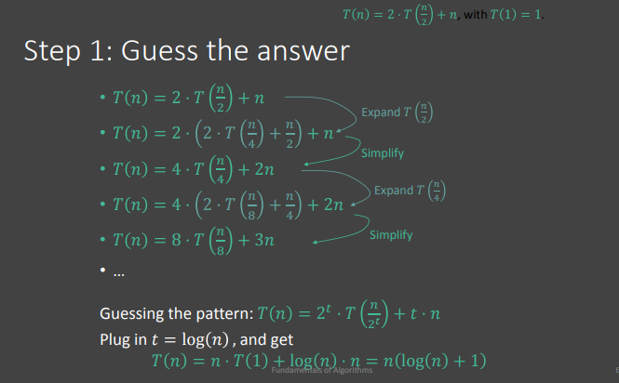

**Step2:**

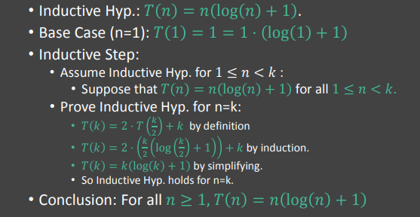

1. For each of the following recurrences, give an expression for the runtime T(n) if the recurrence can be solved with the Master Theorem. Otherwise, indicate that the Master Theorem does not apply.

1. T (n) = 3T (n/2) + n2

2. T (n) = 4T (n/2) + n2

3. T (n) = 2nT (n/2) + nn

4. T (n) = 16T (n/4) + n

Solution:

